Practical 2: Linear and Binary Search: Iterative and Recursive Approaches.
Practical Aim:
To implement linear and binary search using both iterative and recursive approaches.

Problem 1:
A security guard at a parking lot checks vehicles one by one from the entrance to find a car with
a specific license plate. Sometimes he starts from the entrance, sometimes he calls a helper
who starts from where the guard left off. Given a list of license plates and a target plate,
implement both approaches — one that checks plates one by one from the start, and one where
the function calls itself to continue checking — and report the position of the target plate if
found.
Describe the approach you used. What happens in your solution if the target plate appears
more than once in the list? Does it find the first occurrence, the last, or just any one?
Part 1(Linear search):
#include<iostream>
#include<string>
using namespace std;
int main()
{
int ar[10]={1001,1002,1003,1004,1005,1006,1007,1008,1009,1010};
int mid=0,start=0,last=9;
int plate=0,key=0;

cout<<"Enter the plate number : ";
cin>>plate;
for(int i=0;i<=last;i++)
{
mid=(start+last)/2;
if(ar[mid]>plate)
{
last=mid-1;
}
else if(ar[mid]<plate)
{
start=mid+1;
}
else
{
key=mid;
// cout<<"The number is at : "<<mid+1<<"position";
}
}
cout<<"The value/position of Car is : "<<key;
}
Screenshot :
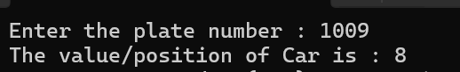
Description:
Searching car plate number with the help of linear search in a known plates.

Part 2(Binary search vehicle number):
#include<iostream>
#include<string>
using namespace std;
int main()
{
int plate[100]={0}; // the capacity of parking is 100

int n=0;//number plate to find
int j=0;//temporary stores how many cars
cout<<"Enter the car number plates and press 0 for exit : ";
for(int i=0;i<100;i++)
{
cin>>plate[i];
if(plate[i]==0)
{
j=i;
break;
}
}
cout<<"Enter the plate number of the car to find: ";
cin>>n;
for(int i=0;i<j;i++)
{
if(plate[i]==n)
{
cout<<"The car with plate number "<<n<<"was at "<<i+1<<"th position"<<endl;
}
}
return 0;
}

Screenshot :
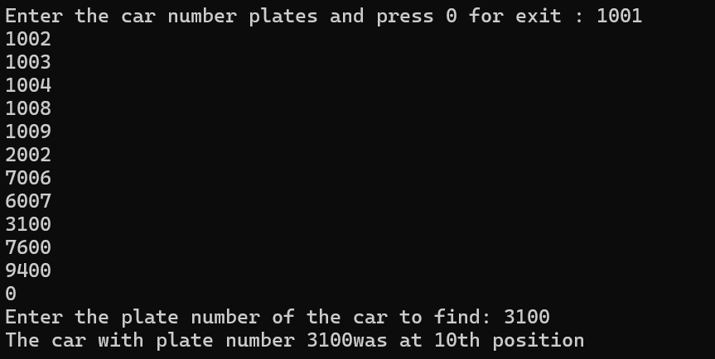

Description:
Enter plate numbers and searching them using binary search.

Problem 2
A librarian maintains a sorted catalog of book codes and needs to locate a specific code quickly.
Instead of going through every book, she opens the catalog to the middle, checks whether the
target is to the left or right, and repeats. Given a sorted list of book codes and a target code,
implement both approaches — one using a loop and one where the function calls itself — and
report the position of the target code.
Describe the approach you used. What is the one condition your input must satisfy for this
approach to work correctly? What would go wrong if that condition was not met?
Part 1(Binary search):
#include<iostream>
using namespace std;

int main()
{
int plate[]={2001,2003,2005,2008,2011,2022,2026};
int size=7;
int n;
cout<<"Enter the book code: ";
cin>>n;
int low=0,high=size-1;
while(low<=high)
{
int mid=(low+high)/2;
if(plate[mid]==n)
{
cout<<"Book code found at position "<<mid+1;
return 0;
}
if(n<plate[mid])
high=mid-1;
else
low=mid+1;
}
cout<<"Book code not found.";
return 0;
}
Screenshot :

Description:
Searching books in library using its code with the help of binary search .

Part 2(Binary search with recursion):
#include<iostream>
using namespace std;

int search(int a[],int low,int high,int key)
{
if(low>high)
return -1;
int mid=(low+high)/2;
if(a[mid]==key)
return mid;
if(key<a[mid])
return search(a,low,mid-1,key);
else
return search(a,mid+1,high,key);
}
int main()
{
int a[]={2001,2003,2005,2008,2011,2022,2026};
int key;
cout<<"Enter book code: ";
cin>>key;
int ans=search(a,0,6,key);//(array,low,high,value/key)
if(ans==-1)
cout<<"Book not found";
else
cout<<"Book found at position "<<ans+1;
return 0;}
Screenshot :
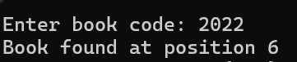

Description:
Searching books in library from book code, but binary search in recursive function.

Conclusion:
The practical successfully implemented linear search and binary search using iterative and recursive approaches. Linear search checks elements sequentially, while binary search repeatedly divides the sorted list into smaller parts to locate the required element efficiently. The practical also demonstrated that binary search requires the input data to be sorted. The iterative approaches use loops, whereas the recursive approaches use repeated function calls. Overall, binary search is more efficient than linear search for large sorted datasets, with a time complexity of O(log n) compared with O(n) for linear search.

